HARDWARE DESIGN SPECIFCATION

FOR THE

MULTI-OIL LEVEL INDICATOR

AUTOMATION OF THE OLS TEST BENCH

ALLEN AIRCRAFT PRODUCTS, INC.

REPORT #250???

PREPARED BY: Rick Ales, R. Ales Consulting LLC

Name, Title

APPROVED BY:

Name, Title

ALLEN AIRCRAFT PRODUCTS, INC.

RAVENNA, OHIO

Revision History

|  |  |  |  |
| --- | --- | --- | --- |
| **Rev** | **Notes** | **By** | **Date** |
| Draft 1 | Initial Draft | R. Ales | 2025/03/02 |
|  |  |  |  |
|  |  |  |  |

Table Of Contents

Paragraph Page

Contents

1.0 Introduction 3

1.1 Reference Documents: 3

1.2 Notation 3

2.0 MOLI Hardware Project Overview: 3

2.1 Hardware Architecture 3

2.1.1 Tank Hardware 4

2.1.2 Instrumentation 5

2.1.3 Interface Unit 6

3.0 Hardware Calibration 8

3.1 Level Measurement Calibration 8

3.2 Resistance Measurement Calibration 8

3.3 Level Control Performance 8

1. Introduction

The following document sets forth both the design specification and the implementation development of the Multi-Level Oil Indicator (MLOI) program for automating the acceptance testing of oil level sensors. The scope of this specification is the hardware, including the tank, pump and instrumentation required for automating production tests of Allen 8005571.05 (P&WC 30Y0241-01) Oil Level Sensor.

* 1. Reference Documents:

TECHNICAL REQUIREMENTS FOR THE MULTI-OIL LEVEL INDICATOR AUTOMATION OF THE OLS TEST BENCH REPORT #250129

TANK, MULTI-UNIT TEST TANK DRW NO. T-20037

* 1. Notation

LV LabVIEW

MLOI Multi-Level Oil Indicator, designation of the automated tester described herein.

AAP Allen Aircraft Products

ATP Acceptance Test Procedure

DS Design or Development Specification

OLS Oil Level Sensor

DUT Device Under Test

AI Analog Input

XL MS Excel

IC Integrated Circuit

1. MOLI Hardware Project Overview:

The project hardware including the tank, pump and instrumentation also has two phases as follows:

* HW 1 – Prototype phase where all items are COTS and custom configurations are achieved through breadboards or otherwise temporary connections.
* HW 2 – Production where custom interfaces have been designed and fit for purpose implemented, ie interface unit manufactured as a custom PCB.
  1. Hardware Architecture

The hardware consists of a tank, the Instrumentation, and an Interface Unit as shown in figure 1. The PC workstation and USB hub are out of scope in this specification.

Figure 1. Hardware Architecture, functional diagram.

Tank Hardware

The dual-chambered tank includes the with the following components:

* Reservoir is the chamber containing the bulk of the oil <spec/description??>
* Measurement Well is the chamber into which the sensors are immersed for measurement.
* Senor Rack Plate holds the sensors in place during measurements and provides the sensor reference level datum.
* Leveling Feet for leveling the Sensor Rack Plate to the oil level.
* Transfer Pump GP-201-12/24L for transferring oil between the Reservoir and the Measurement Well.
* Miscellaneous brackets for mounting instrumentation.
  + - 1. The Tank / Pump open loop system response

Using the Pololu MC18V7 PWM motor controller with Vs set to 24Vdc, The Δ Level was measured for 30 seconds at various percent of max speed (100% duty cycle) for both FILL and DRAIN at near EMPTY and near FULL.

The response has a minor shift at each case but is basically linear down to about 5% resulting in fill rate of about 0.1”/min where the control becomes unstable by 4% as shown in the ‘Zoomed In Plot.

Without doing an extensive fluid analysis, this response is assumed to be adequate for the MLOI application. Data from mloi:\PM_Folder\_3 Develop\Design Calculations.xlsx sheet Tank. 3/4/2025 R. Ales

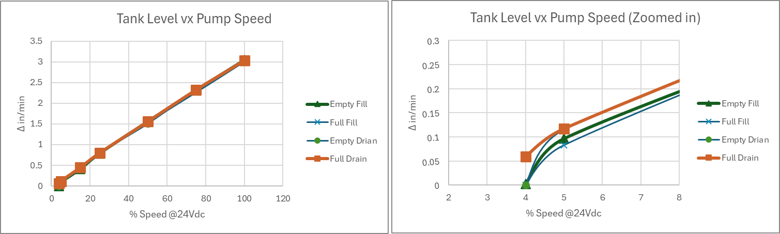

Figure 2. Tank / Pump level response.

* + - 1. Step settling with 3-speed Servo Pump Control

As currently designed, the Pump is controlled by a 3-speed servo controller implemented in LV. The Pump is driven at FAST, SLOW and Creep speeds over the corresponding speed ranges based on the error (Set Point minus Process Variable, e = SP – PV) Thes “pump parameter” are setable in the $Configuaation File where speed is specified in terms of percent of maximum Pump flow rate of 100%. Figure 3 shows the level step at 600Ω filling towards 700Ω. Figure 4, shows the level zoomed-in to the 0.001” per tick, over the 3-second pause for measurement.

Instrumentation

The instrumentation provides Level measurement (Keyance Laser LK-G2000) and two resistance measurements for each sensor DUT (DataQ DI2108) and provides directional DC motor control (Pololu MC18V7) via Univeral Serial Bus (USB).

* + - 1. Level Measurement - Keyance Laser LK-G2000
      2. Resistance Measurement -DataQ DI2108

The DI-2108-P data acquisition instrument is a portable data recording module that communicates through your computer's USB port. Power is derived from the interface port so no external power is required. Features include:

Analog Inputs

Number of Channels: 8

Channel Configuration: Differential

Measurement range per channel: Programmable ±2.5, ±5, ±10, 0-5, 0-10 Volts

Input impedance: 800 kΩ differential

DC accuracy: ±0.05% of range 25°C

Absolute maximum input: ±150 V dc or peak ac

ADC Characteristics

Resolution: 16-bit

Resolution applied to measurements: >15.6-bit

Max. sample throughput rate: 160 kHz throughput

Min. sample throughput rate: Hardware: 1.831 kHz

with WinDaq software: 0.305 Hz

Sample rate timing accuracy: 100 ppm (typical over 24 hours)

Digital Ports

Number of Ports: 7

Type: MOSFET switch

Configuration: Programmable as digital input or switch

Pull-up value: 4.7 kΩ

Input high voltage threshold: 2.4V

Input low voltage threshold: 0.8V

Absolute maximum applied voltage (V): 0 ≤ V ≤ 25 V

* + - 1. Motor Controller - Pololu MC18V7

Interface Unit

The interface unit provides one fixed current reference circuit (Is) as sensor signal stimulus to a single sensor channel so sensor channel resistance (Rchx) can be calculated from the sensor signal (Vm):

Rchx = Vm / Is where Vm is the measured voltage from the sensor.

The interface unit also provides a one buffer/scaler circuit to condition a single Sensor signal to the range of corresponding Analog Input (AI).

The interface unit provides a place to mount the Pololu Motor Controller. It also provides a means to connect the system components including the Power Supplies, to Laser and moto controller; and connect the sensor signals to the analog inputs.

* + - 1. Reference Current Source Circuit

The Current Source required to drive the sensor signal is implemented with one Linear Technologies LT3092 integrated circuit (IC) for each sensor channel. Parameters for consideration are the reference current (Is) as determined by the in situ current of the OLS to be tested; the compliance voltage (Vdc) determined from the required maximum resistance to be measured at Is. The Elevate OLS resistance ranges from 100Ω - 1100Ω with an overrange resistance of 2100Ω with an in situ of 14.7ma, producing a maximum signal voltage Vs of 16.7V at 1100Ω. We assume that the overrange resistance does not have to be accurately measured, only detected and that the Laser uses a 24VDC source that can be used to power the Current Source circuit Vdc, where the maximum resistance measurement will be 1632Ω. With Vdc set to nominal 224VDC following the LT3092 Datasheet Application Information page 9. Then 15Ω is selected for ROUT and 22.0KΩ is calculated for RSET as shown in Figure 2.

Figure 2. LT3092 Current Source Circuit

* + - 1. Buffer/Scaler Circuit

The Buffer/scaler circuit addresses two issues with the DI-2108:

* Limited input voltage range
* Relatively low input impedance.

To achieve Rin > 1MΩ, a LM2902 unity gain, follower circuit will buffer and isolate the DUT from the Analog Input impedance. With maximum signal voltage Vs > 16.7V and the maximum input voltage range of the DI-2108 of +/-10.0V, then Vs must be scaled to fit within the input range. This accomplished with voltage divider circuit consisting of R7 (R9) and R8 (R10). where the parallel resistance (Rin = R7 || R9) is greater than 1MΩ. To achieve Rin > 1MΩ, the relatively low 100KΩ input resistance of the DI-2108 shown in Figure 3 needs to be increased by adding a single supply, follower op amp (LM2902).

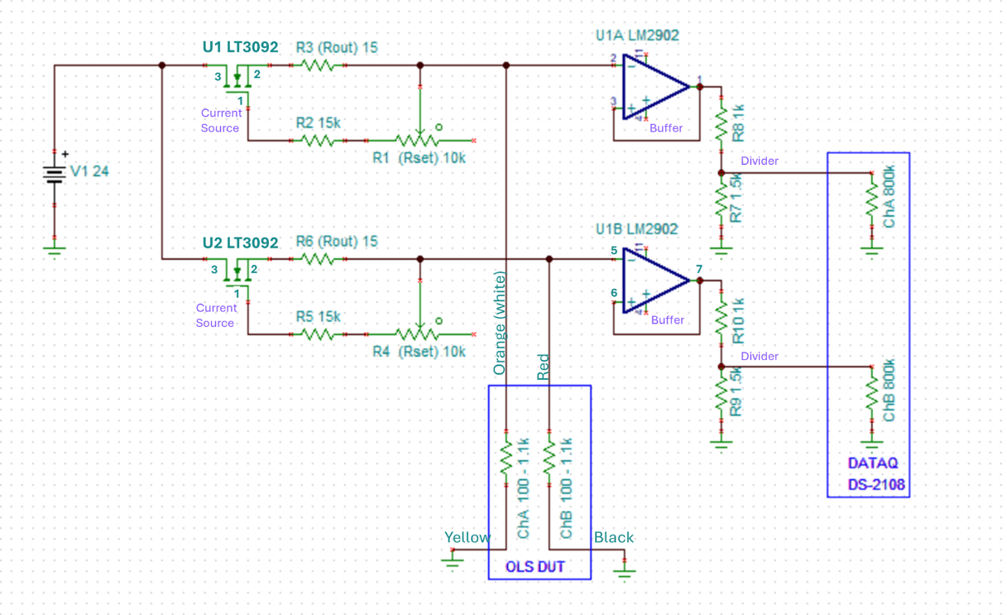

Figure 3. Analog Input Circuit

Connectors

* + - 1. Breadboard implementation
      2. PCB implementation

1. Hardware Calibration
   1. Level Measurement Calibration
   2. Resistance Measurement Calibration
   3. Level Control Performance